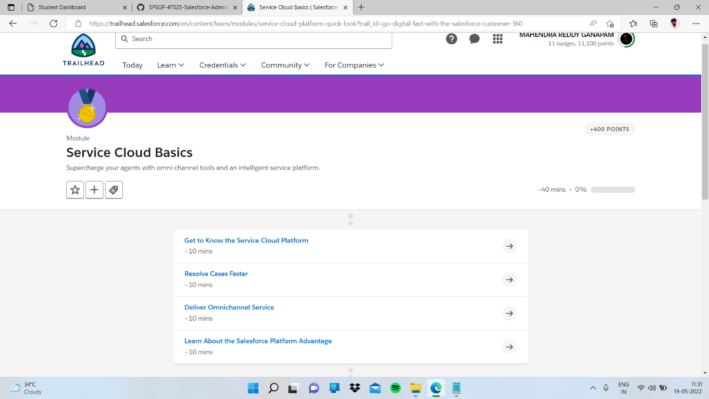

Sub topic:- Deliver Omnichannel Service

In this I completed quiz

